**Session 1**

1. Create a Thread by extending the Thread class.

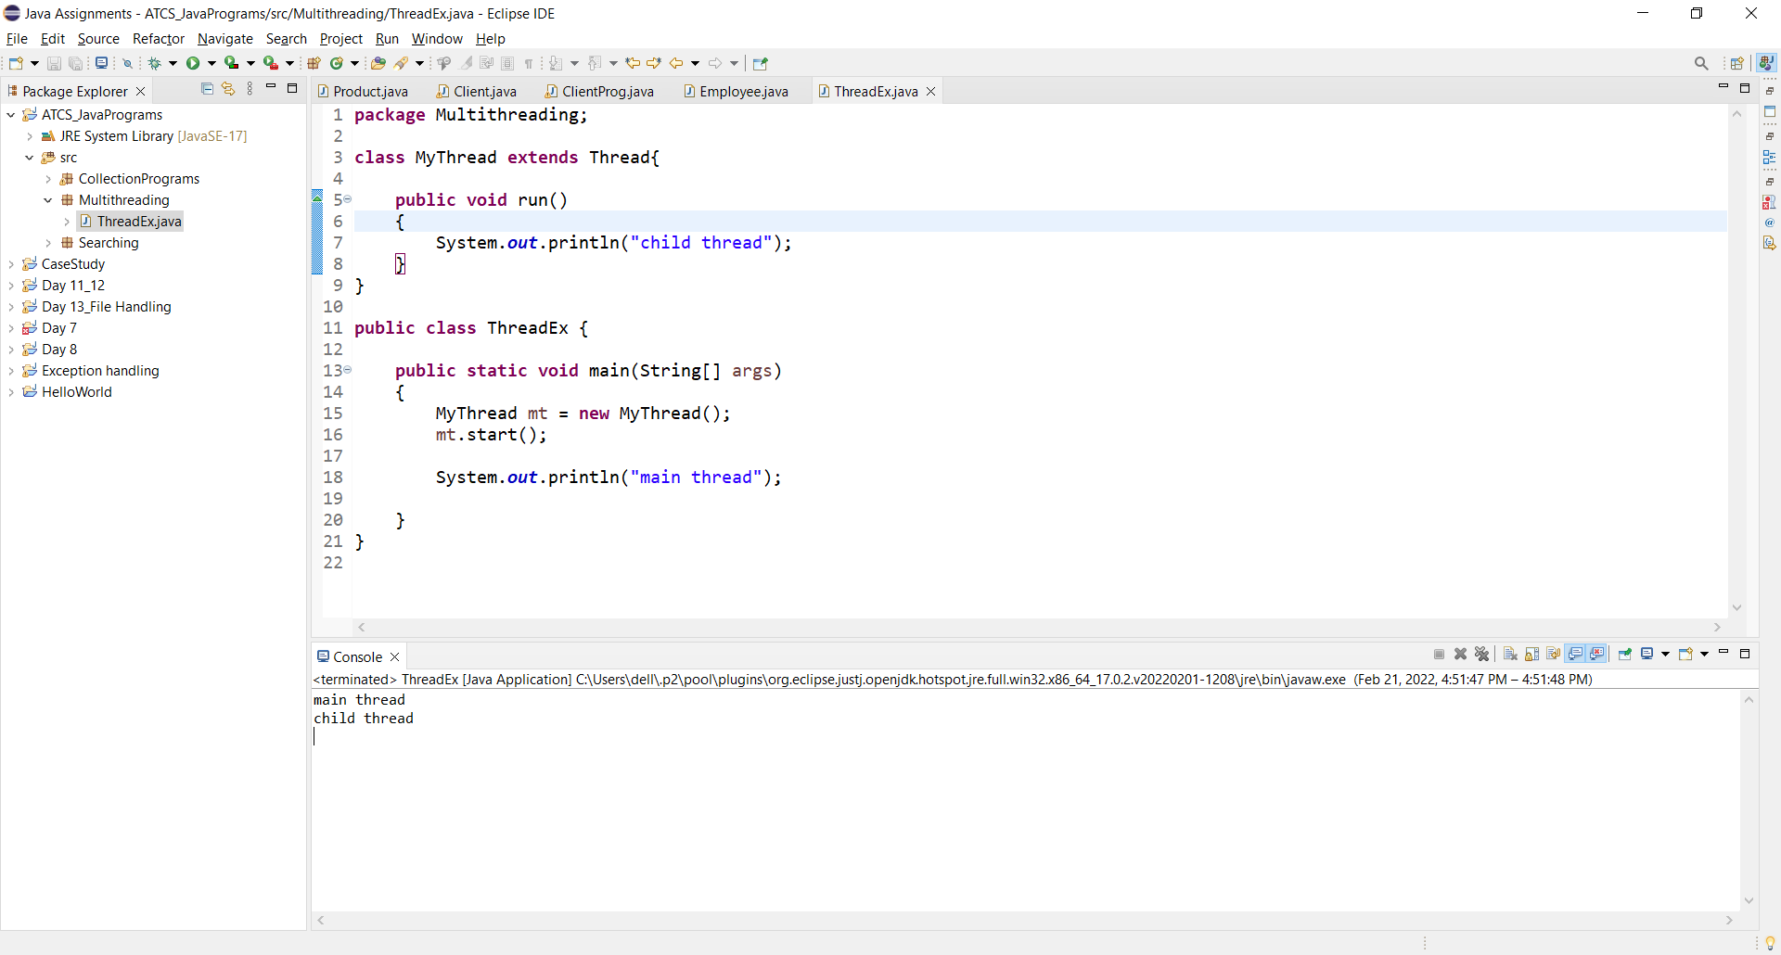

1. Create a Thread by Implements the Runnable Interface.

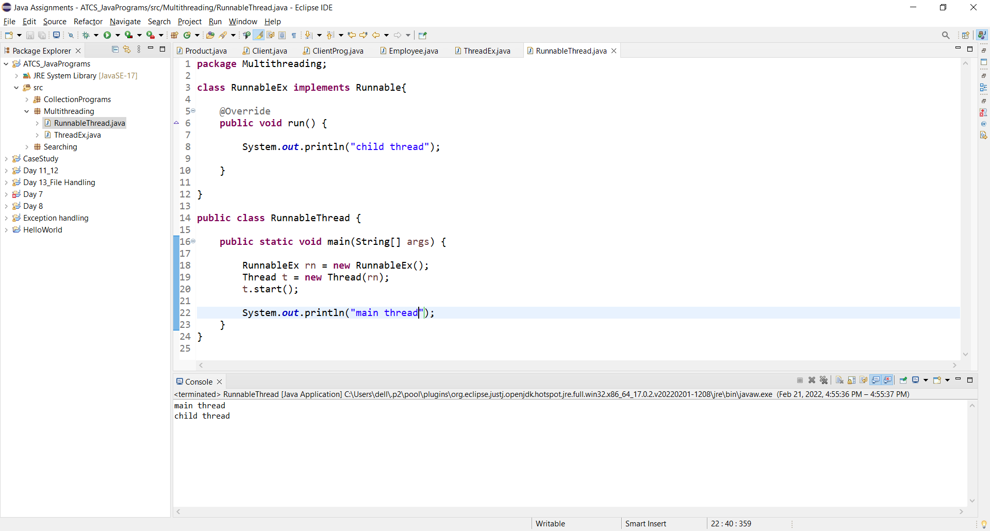

1. Create a Thread by extending Thread class set and get the name of thread.

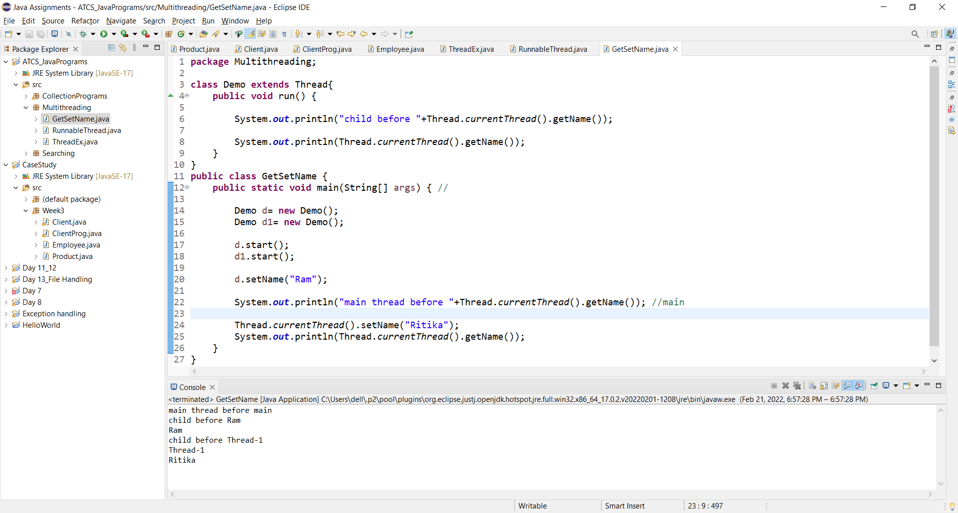

1. Create a Thread by extending Thread class set and get the priority of thread.

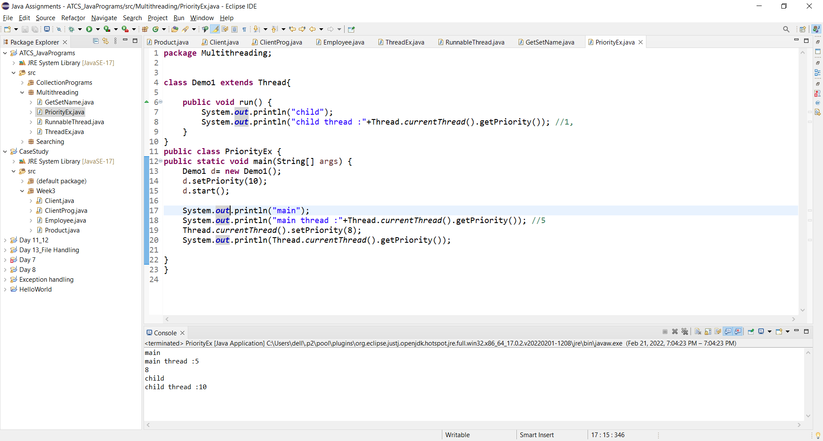

1. Create a Thread by extending Thread class apply Yield Method.

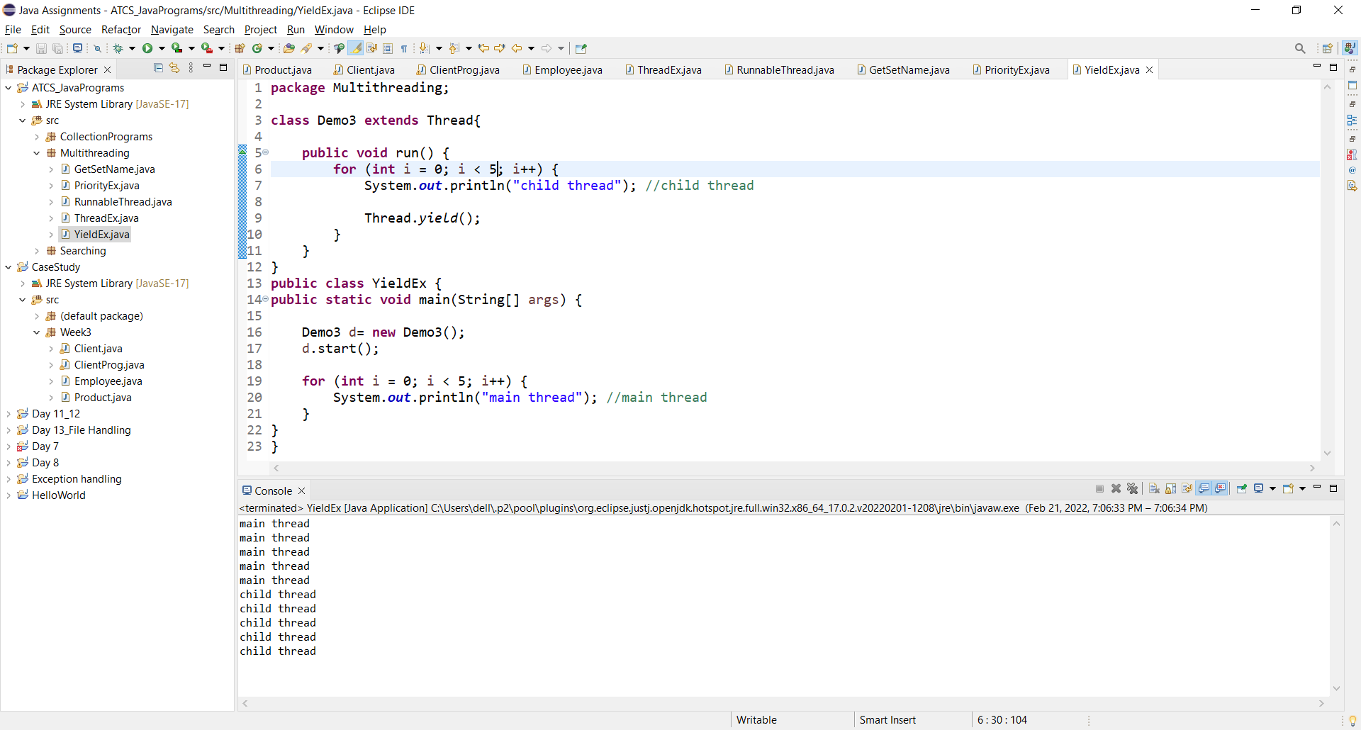

1. Create a Thread by extending Thread class apply join Method.

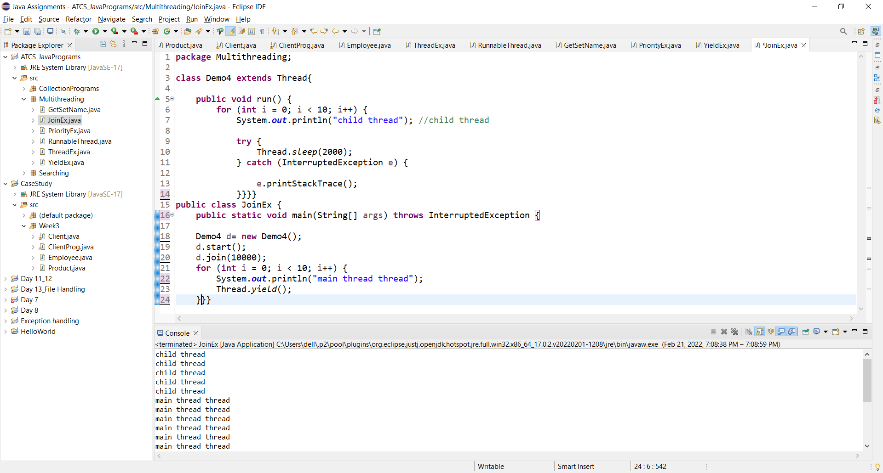

1. Create a Thread by extending Thread class apply sleep Method.

